2019 NJHS shirt order form
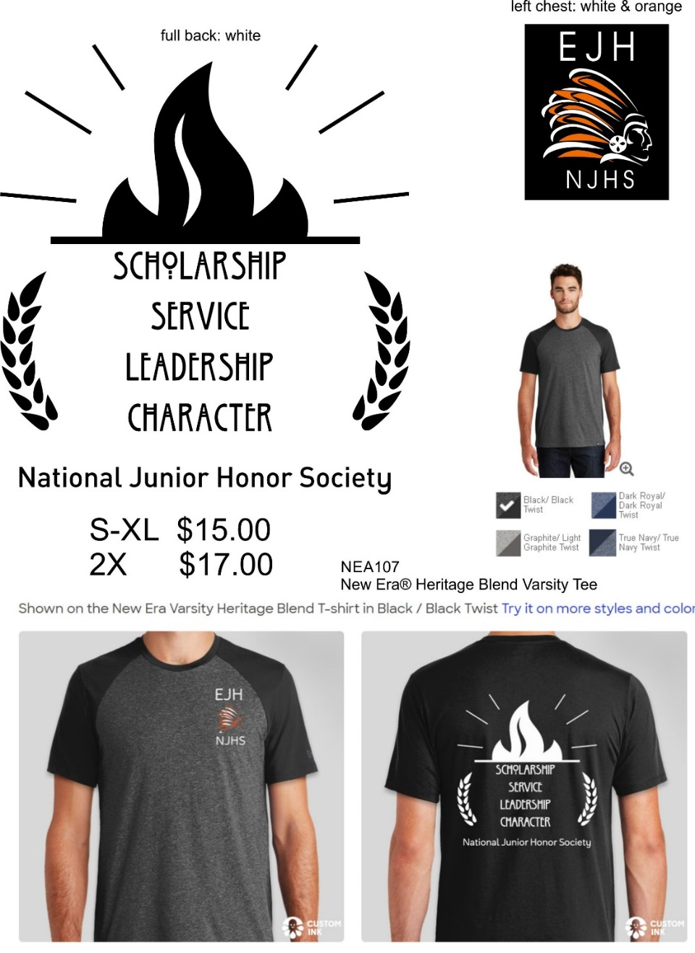
Money (exact change or check made out to Eppler Junior High) due December 11, 2019

Long sleeve available in heather gray:
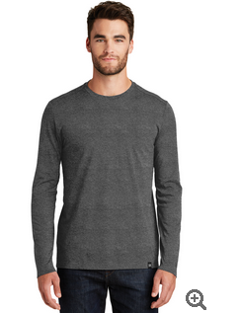

Name ____________________________________________________
Shirt size: __________ short or long sleeve _________Total: _________

